Lab 1.
Start the Hugs interpreter.
In interpreter mode
1. Calculate a numeric expression.
2. Calculate the logical expression (you can convert it beforehand using the mathematical logic).
Create a file with *.hs extension. Write in it:
3. The myexpr function (having determined the type and the required number of arguments on its own), which allows you to calculate the expression from the task 1. Make sure that the answers are equal. Demonstrate how the function works with some 3 sets of arguments that are different from the initial ones (in task 1).
Working with list functions.
4. Check the result of the expression calculation in the interpreter and explain it.
5. Define a function in the file that performs the specified action on the lists.
Working with simple recursive functions.
6. Define functions for calculating Fibonacci numbers by number and for calculating factorial. Use them to define your own function, written in conditional mathematical notation. (fib(n) - means the nth Fibonacci number).

Save the results of your work as screenshots and paste them into the report.

Variant 1.
1. 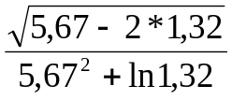
2. «It is not true that if the number four times less than the number preceding the number 54 is greater than the square root of 225, then the sum of the list of the first three prime natural numbers is even»
4. elem (head (drop 1 “abd”)) (tail (tail “abcdef”))
5. Given two lists, returns a list that contains the elements of the shorter list in reverse order.
6. F(n,m)=fib(n+m+1)-min{n!,m!}

Variant 2.
1. 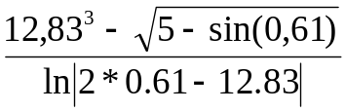
2. Each of the three statements is true: 1) the difference of the squares of 18 and 24 does not exceed their least common multiple 2) the first element of the tuple (5,4) is an odd number 3) the product of the elements of the list [2,5,4] is greater than ten times the last element
4. ([3,4,7,8] !! (last [1,2,3])) : (drop 2 [1,2,3,4,5])
5. Returns the maximum element of 4 numbers - the last two and the first two elements of the given numeric list.
6. F(n)=(n-1)! - fib(2*n+1)

Variant 3.
1. 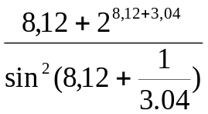
2. Only one of two statements is true: 1) the remainder of 84 divided by 9 is not greater than the square root of 5 2) the second element of the tuple (“a”,,”b”) is included in the string “abcdef”, which was reversed and removed after that 2 first elements.
4. replicate (minimum [5,6,3,4]) (“abcdef” !! 4)
5. Returns a list of indices corresponding to the maximum element of the given list.
6. F(n,m,l)= fib(n!+2*max{m,l}-min{m,l})

Variant 4.
1. 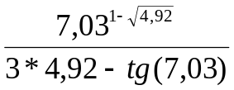
2. «If the difference between the maximum and minimum elements of the list [1,2,3,4,5] is odd, then the third element of this list is not equal to the minimum».
4. snd (3,5) : init [1,2,3,4,5] == [5,1,2,3,4]
5. Replaces all occurrences of the given character in the given list-string with another given character.
6. 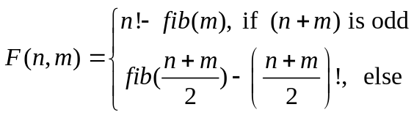
Variant 5.
1. 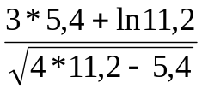
2. At least one of the statements is true: 1) the second element of the list [8,1,3,4] is greater than the first 2) the least common multiple of the numbers 27 and 36 does not exceed the maximum of these numbers 3) the last element of the string "victory" is contained in the string, glued from the strings "my", "sweet", "home".
4. elem (length “abcd”) (reverse (tail [3,4,8,6]))
5. Returns a sublist of the given list, starting at some given index and ending at some.
6. F(n,m,l)=min{m!,l!}-fib(max{n,m})

Variant 6.
1. 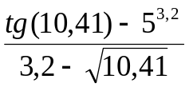
2. Either both statements are true at the same time, or both are false. 1) the character following the character ‘m’ (in the ASCI table) is contained in the string “bingo” 2) the sum of the elements of the tuple (3,4) is odd.
4. drop (last (reverse [2,3,4,5])) [1,2,3,4,5,6]
5. Returns the product of all elements of a numeric list except the maximum.
6. F(n)=min{fib(n!),(fib(n)-n)!}

Variant 7.
1. 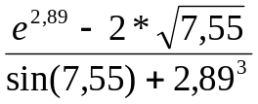
2. It is not true that both statements are true: 1) The product of the elements of the list [2,3,-5,1] is odd 2) the string "abcdef", from which the last 2 characters have been removed, will have a length of less than 5.
4. (init [1,2,3]) : (replicate 3 (drop 2 [1,2,3,4]))
5. Calculates the sum of the even elements of a numeric list.
6. F(n,m)=(n mod m)! +fib(m mod n)

